ColourShift
ASLAN SE 71

Opaque dichroic film with four effects
As colourful as pictures of our planets are these four dichroic, self-adhesive films. The opaque films are mainly suitable for indoor applications and are first choice for eye-catching plotted claims, slogans, wall tattoos, logos etc. Changing viewing angles or lighting create a stunning fluent colour change.

Use it to create memorable campaigns so that people will remember shops, exhibition stands, brands etc. These colours are available: Aurora (pink to light blue, item no. 13142S), Alpha (magenta to yellow, item no. 13143S), Andromeda (copper to green, item no. 13144S) and Plasma (dark blue to green, item no. 13145S).

For further information or questions regarding special applications please contact our technical advisory service: +49 2204 70880

Construction
Face film: |  | Polyester
Thickness: |  | ~ 160 μm (~ 6.3 mil)
Adhesive: |  | pressure sensitive polyacrylate | Square quantity: ~ 25 g/m²
Release liner: |  | double-sided PE coated paper | Square weight: ~ 140 g/m²
Characteristics
Adhesive strength (ASTM D903): | Immediately: ~ 1,5 N/25 mm After 72 hours: ~ 12 N/25 mm
Temperature: | Application temperature: min 15 °C (59 °F)  Service temperature range: -30 °C (-22 °F) up to +80 °C (176 °F)
Durability: | Up to 2 years outdoors, with vertical exposure, in central European standard climatic conditions.
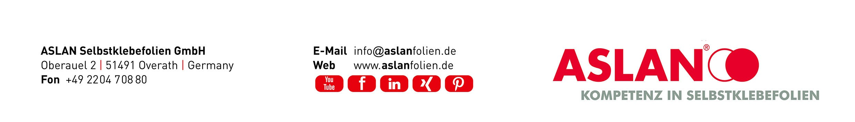

ColourShift
ASLAN SE 71

Processing
Digital cutting: | The film can be cut using a flatbed cutter as well as a roll cutter with tangential head using a 60° knife. The vertical height of capital letters should not be smaller than 40 mm with a width of min. 10 mm. Opened rolls should be wrapped tightly around the core and stored with an adhesive label. We recommend using the film from one production batch for a uniform effect in the same projects.
Application: | Application dry or wet. If applied wet, a possible whitening of the adhesive occurs but will fade away after a couple of days depending on the weather. For wet application we recommend the transfer liquid ASLAN TL10. For the application of fonts etc. we recommend our ASLAN application tapes respectively the ASLAN TMO.  Applying wet makes positioning easier. Please pay attention to the fact that water diffuses poorly through the film’s polyester surface. In these cases, water has to be pressed out completely and carefully by using a squeegee.  The ColourShift ASLAN SE 71 can only be applied on smooth and even surfaces and is not suitable for curved surfaces. The film should not be applied on outgasing surfaces like non-tempered acrylic glass.  To bring out the colour effect as ideally as possible, the substrate should be absolutely smooth and homogenous as well as free of dust, grease and lint. Cleaning agents should be carefully removed from the surface and finally be cleaned with clear water.  To receive a homogenous look, each sheet of film should always be applied in the same direction to avoid contrary colour effects. Combinations of vertical and horizontal applied sheets are not recommended.
Storage life: | Before application the films can be stored up to 2 years from date of production. The film must be stored at room temperature (15-25 °C / 59-77 °F) and at a relative air humidity of 5060%. To avoid pressure points appearing on the roll surface, we recommend the rolls be stored either standing vertically or in a purposely designed `hanging ́ racks.
State 4|2022 | All technical data and advice is based on our experience and measured testing that we believe to be reliable. It remains the customer’s responsibility to test the suitability of our products for the intended purpose.  The quality of our products is regularly examined, upgraded and developed. We take the right, without prior notice, to adjust, upgrade and improve the chemical structures or physical characteristics of our products in accordance with our latest knowledge.

