Architectural Solutions Product Overview Page 1 / 2
Avery Dennison®
Organoid Natural Surfaces
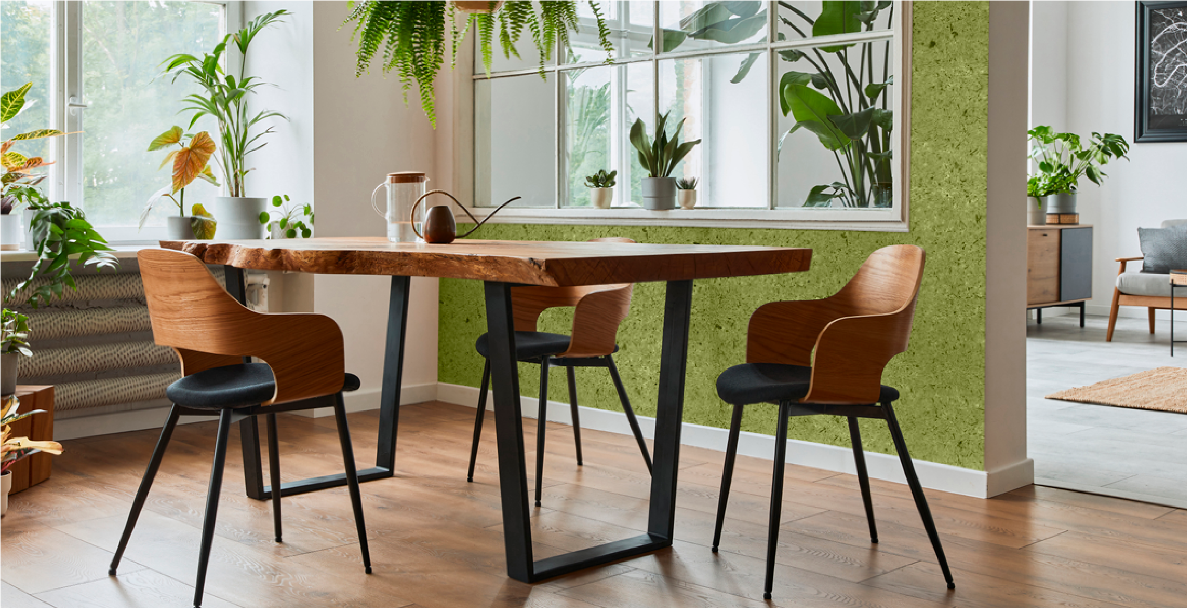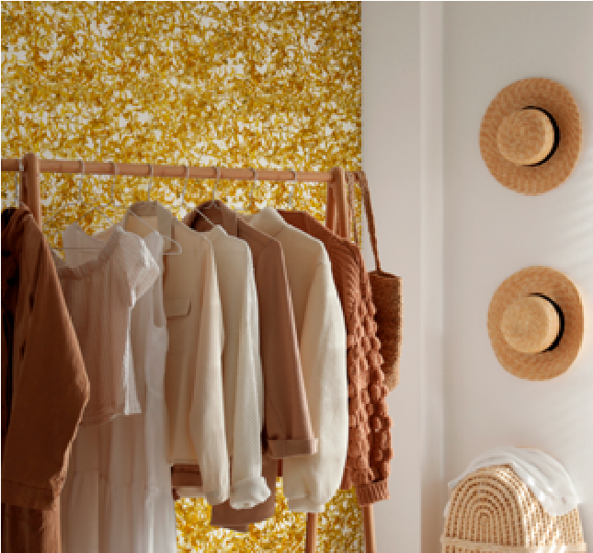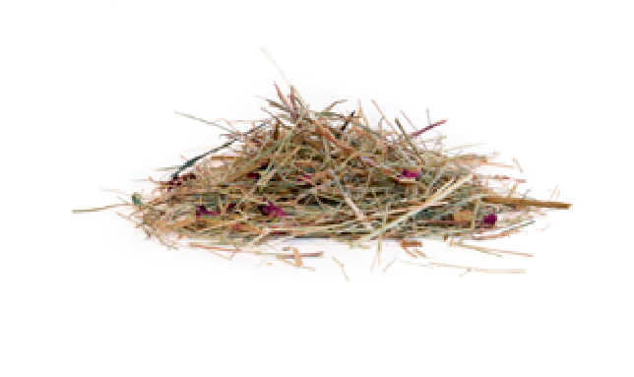
Authentic handcrafted materials with
self-adhesive backing - Avery Dennison
®

Organoid Natural Surfaces offer endless
unique, nature-inspired interior design
possibilities. All with direct bonding from
smooth, plastered and painted walls to
textured concrete surfaces, as well as
windows.
The Avery Dennison
®
Organoid Natural
Surfaces Interior Decoration product line
enables you to bring the outside in and
makes every space a truly unique experience.
Using natural raw materials, the Organoid
products provide a one of a kind experience,
engaging almost all of your senses.
Personalise the look of your interior, feel the
unique texture, and smell nature’s original
fresh scents. Be the first to explore a new way
of evoking novel reactions to interior design.
The abundance of nature offers everything
needed for natural surfaces - from alpine hay
to dark moss, and from rubber tree leaves
to rose petals. Inspired by nature, Organoid
products are produced with organically and
regionally produced raw materials wherever
possible. The philosophy is to avoid further
processing via conventional production,
relying instead on regional partners and
short transport routes.
See. Feel. Smell.
Architectural Solutions Product Overview Page 2 / 2

KEY FEATURES  - PVC free - 100% natural face materials  - 7 different natural surfaces for interior decoration  - Available in opaque and translucent finishes  - Designed for indoor use  - Permanent High Tack adhesive  - 5 years indoor durability  - All items are available in rolls of 1.36m x 10m | KEY BENEFITS  - A new way to decorate interior windows and walls  - Authentic and natural indoor visual communication and design  - Suits any architectural and interior style  - Can be applied on many different wall structures  - Easy to apply and to maintain  - Transforms every space into a truly unique experience

Available Products
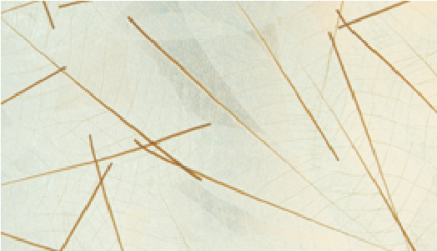
Skellett Leaves (Translucent) With its green colour removed, the delicate skeleton of a real dried rubber tree leaf conveys a feeling of lightness.
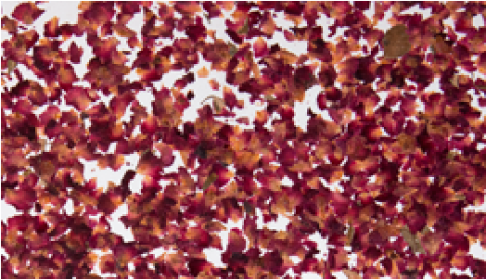
Rose Petals (Translucent) Highly fragrant and vibrantly colourful petals, with no artificial colours or fragrances added.
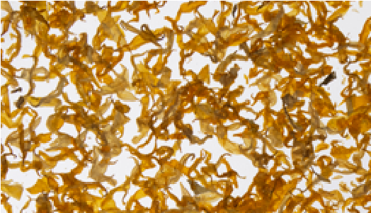
Sunflower Petals (Translucent) These popular yellow petals combine a natural surface with a translucent self-adhesive film, for special light effects.
NATURAL RAW MATERIALS
- See it - with authentic material compositions in unique colours
- Feel it - experience the original structure of the natural material
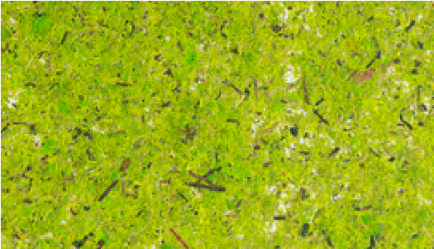
- Smell it - enjoy the pure fragrance of a natural material

Moss Bright Green
A true blaze of colours, with a
subtle scent, and a true natural feeling.

Moss Dark Green
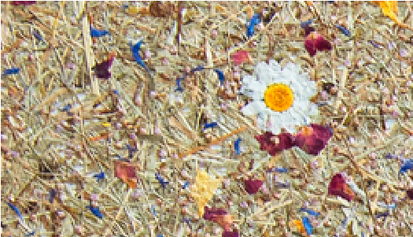
A natural surface that comes with a cozy blaze of coloured accents and a subtle scent.

Mountain Hay + Marguerites
Notes of a colourful alpine Meadow. Generously scented alpine grass along with petals of arnica, cornflower, heather, roses and marguerites with stem.

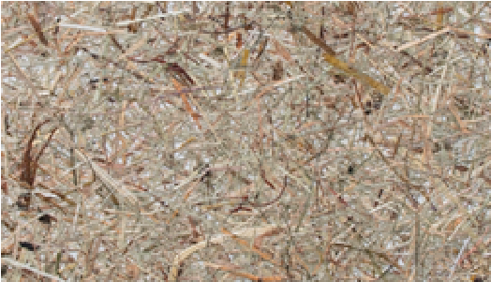
Original Alpine Hay
Naturally scented alpine-hay and herbs from the Tyrolean Alps. Hand-cut and lovingly processed.

Organoid Natural Surfaces are part of the Avery Dennison Wall & Window Collections Learn more on: graphics.averydennison.eu/organoid

graphics.averydennison.eu Facebook LinkedIn Instagram
DISCLAIMER — All Avery Dennison statements, technical information and recommendations are based on tests believed to be reliable but do not constitute a guarantee or warranty. All Avery Dennison products are sold with the understanding that purchaser has independently determined the suitability of such products for its purposes. All Avery Dennison’s products are sold subject to Avery Dennison’s general terms and conditions of sale, see http://terms.europe. averydennison.com
©2021 Avery Dennison Corporation. All rights reserved. Avery Dennison and all other Avery Dennison brands, this publication, its content, product names and codes are owned by Avery Dennison Corporation. All other brands and product names are trademarks of their respective owners. This publication must not be used, copied or reproduced in whole or in part for any purposes other than marketing by Avery Dennison.
2021_30844 EN

